Ye,Zhengkun

Project 4

03/10/2014

**import** javax.swing.JOptionPane;

**public** **class** Oldest {

**public** **static** **void** main(String[] args) {

String name;

String oldestName, oldestName2;

Integer age;

Integer oldestAge;

name = "";

oldestAge = 0;

oldestName = "";

oldestName2 = "";

age = 0;

// Data entry

name = JOptionPane.*showInputDialog*("Enter a name: ");

**while** (!name.equalsIgnoreCase("quit")) {

age = Integer.*parseInt*(JOptionPane.*showInputDialog*("Enter an age: "));

**while** (age < 0) {

age = Integer.*parseInt*(JOptionPane.*showInputDialog*("Age must be greater than zero: "));

}

**if** (age > oldestAge) {

oldestName = name;

oldestAge = age;

oldestName2 = "";

} **else** **if** (age == oldestAge) {

oldestName2 = name;

}

name = JOptionPane.*showInputDialog*("Enter a name: ");

}

**if** (oldestName == "") {

JOptionPane.*showMessageDialog*(**null**, "No oldest.");

System.*out*.println("No oldest");

} **else** {

JOptionPane.*showMessageDialog*(**null**, "Oldest is: " + oldestName + "." + "\nTheir age is " + oldestAge);

System.*out*.println("OldestName");

}

**if** (!oldestName2.equalsIgnoreCase("")) {

JOptionPane.*showMessageDialog*(**null**, "Co-oldest is: " + oldestName2 + ".");

System.*out*.println(oldestName);

}

}

}

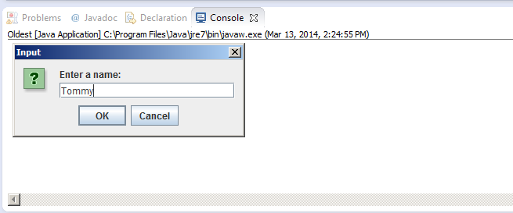

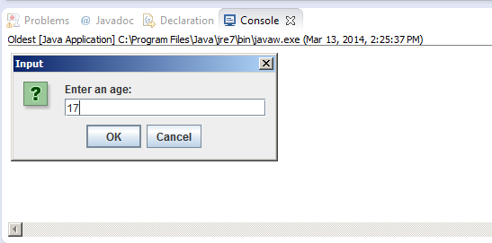



**import** java.util.Scanner;

**public** **class** ParkingGarage {

**public** **static** **void** main(String[] args) {

**int** g,h,i,j,k,l;

g=0;

h=0;

i=0;

j=0;

k=0;

**double** f;

Scanner sc = **new** Scanner(System.*in*);

System.*out*.println("Enter the hours parked for car 1: ");

**double** a = sc.nextDouble();

System.*out*.println("Enter the hours parked for car 2: ");

**double** b = sc.nextDouble();

System.*out*.println("Enter the hours parked for car 3: ");

**double** c = sc.nextDouble();

System.*out*.println("Enter the hours parked for car 4: ");

**double** d = sc.nextDouble();

System.*out*.println("Enter the hours parked for car 5: ");

**double** e = sc.nextDouble();

**if**(a<=2)g=5;

**else** **if**(2<a && a<=3) g=6;

**else** **if**(3<a && a<=4) g=7;

**else** **if**(4<a && a<=5) g=8;

**else** **if**(5<a && a<=6) g=9;

**else** **if**(6<a && a<=7) g=10;

**else** **if**(7<a && a<=8) g=11;

**else** **if**(8<a) g=12;

**if**(b<=2)h=5;

**else** **if**(2<b && b<=3) h=6;

**else** **if**(3<b && b<=4) h=7;

**else** **if**(4<b && b<=5) h=8;

**else** **if**(5<b && b<=6) h=9;

**else** **if**(6<b && b<=7) h=10;

**else** **if**(7<b && b<=8) h=11;

**else** **if**(8<b) h=12;

**if**(a<=2)i=5;

**else** **if**(2<c && c<=3) i=6;

**else** **if**(3<c && c<=4) i=7;

**else** **if**(4<c && c<=5) i=8;

**else** **if**(5<c && c<=6) i=9;

**else** **if**(6<c && c<=7) i=10;

**else** **if**(7<c && c<=8) i=11;

**else** **if**(8<c) i=12;

**if**(d<=2)j=5;

**else** **if**(2<d && d<=3) j=6;

**else** **if**(3<d && d<=4) j=7;

**else** **if**(4<d && d<=5) j=8;

**else** **if**(5<d && d<=6) j=9;

**else** **if**(6<d && d<=7) j=10;

**else** **if**(7<d && d<=8) j=11;

**else** **if**(8<d) j=12;

**if**(e<=2)k=5;

**else** **if**(2<e && e<=3) k=6;

**else** **if**(3<e && e<=4) k=7;

**else** **if**(4<e && e<=5) k=8;

**else** **if**(5<e && e<=6) k=9;

**else** **if**(6<e && e<=7) k=10;

**else** **if**(7<e && e<=8) k=11;

**else** **if**(8<e) k=12;

f=a+b+c+d+e;

l=g+h+i+j+k;

System.*out*.println("Total Hours" + f);

System.*out*.println("Total Charge $" + l);

}

}

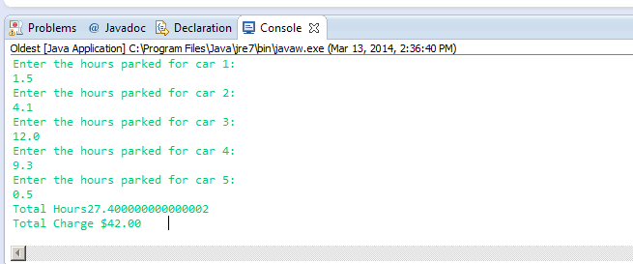

**import** java.util.Scanner;

**public** **class** CountingChange {

**public** **static** **void** main(String[] args) {

**int** dimeCount, quarterCount, nickelCount, pennyCount;

quarterCount = *getInput*("Quarters");

dimeCount = *getInput*("Dimes");

nickelCount = *getInput*("NIckels");

pennyCount = *getInput*("Pennies");

}

**public** **static** **int** getInput(String item) {

Scanner input = **new** Scanner(System.*in*);

System.*out*.print("Enter number of " + item + ": ");

**return** input.nextInt();

}

}

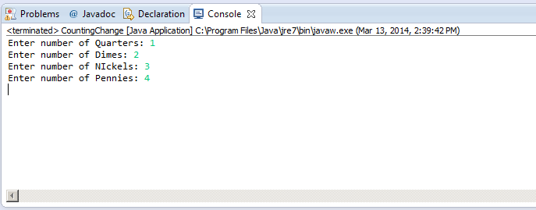

**import** java.util.Scanner;

**public** **class** SecretNumber {

**public** **static** **void** main(String[] args){

**int** random1, answer;

Scanner input = **new** Scanner(System.*in*);

random1 = (**int**)(Math.*random*()*10);

System.*out*.print(random1);

System.*out*.println("Guess the number");

answer = input.nextInt();

**while**(answer != 0) {

**if** (answer > (random1 + 30)){

System.*out*.println("Way to high");

}

**else** **if** ( answer < ( random1 - 30)){

System.*out*.println("Way to low");

}

**else** **if** (answer > random1 + 10 && answer <= random1 + 30){

System.*out*.println("High");

}

**else** **if** (answer < random1 - 10 && answer >= random1 - 30 ){

System.*out*.println("Low");

}

**else** **if** ( answer > random1 && answer <= random1 + 10){

System.*out*.println("A little high");

}

**else** **if** ( answer < random1 && answer >= random1 - 10){

System.*out*.println("A little low");

}

**else** **if** ( answer == random1){

System.*out*.println("That is correct");

System.*exit*(0);

}

System.*out*.println("Guess the number");

answer = input.nextInt();

}

}

}

